Good explanation on what git is and how to install it for Rails:
https://www.railstutorial.org/book/beginning#sec-bundler

Once you have done all that and your app is under version control, use heroku to put your app into production.

Github is a work platform where your code is present throughout the dev process. Each modification is cataogued, or commited, which allows you to implement version control.

Apart from github, there is git, a software created by torwald. There are two types of control software: one with central control (one server for everybody), or distributed, which is more like peer to peer.

Terminal usage (advanced)

Install putty: it allows to communicate between the comp and a server, or access a distant machine connected to the internet in general.

Then launch the program, and specify the Host Name or IP adress of the machine you want to access in the top right corner

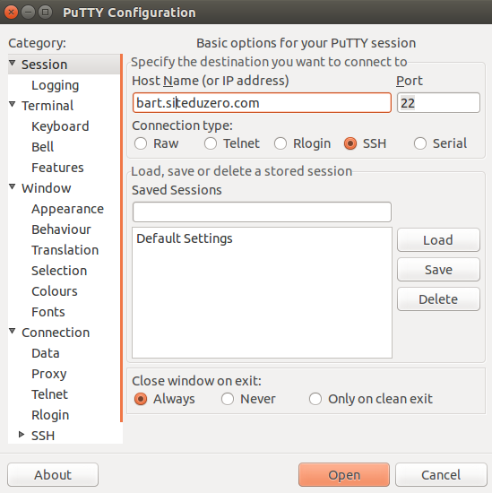

GIT

Is rly good. It's the local version of github.

After placing yourself in the workspace, set the folder as a git repository with
$: git init

$: git add file_to_commit.txt

$: git commit -a -m 'comment for the commited file'

Vizualizing the historial of commits

$: git log

Getting back to a previous commit:

$: git checkout cbd9724fd10451bef261c2812b072c48a5cf93ca (log version)

Going back forward (main branch):

$: git checkout master

Github

git init
git add README.md
git commit -m "first commit"
git remote add origin https://github.com/piotrkaczmarek19/snake-js.git
git push -u origin master

Gists: Easy way to share bits of code.

Recuperer du code for the first time (clone):
$: git clone http://url_of_project

Sending code from Git to github:
$: git push origin master

Retrieving a modification (without creating a clone):
$: git pull

Creating and moving to new branch:
$: git checkout -b new-branch

Fusing branches together:
$: git checkout master
$: git merge branch_to_be_merged

Solving conflicts (merging two branches that have the same file modified twice):
Modify the merged file & save
$: git commit
$: git checkout branch1
$: git merge branch2

Know who did a modification
$: git blame file_name.md
$: git show cat_number_of_modif

Pour des raisons de sécurité et de clarté, il est important d'ignorer certains fichiers dans Git, tels que :
- Tous les fichiers de configuration (config.xml, databases.yml, .env...)
- Les fichiers et dossiers temporaires (tmp, temp/...)
- Les fichiers inutiles comme ceux créés par votre IDE ou votre OS (.DS_Store, .project...)
Le plus crucial est de ne JAMAIS versionner une variable de configuration, que ce soit un mot de passe, une clé secrète ou quoi que ce soit de ce type. Versionner une telle variable conduirait à une large faille de sécurité, surtout si vous mettez votre code en ligne sur GitHub !
If you are in the middle of some modifications and you suddenly have to commit your branch to github, use stash:
$: git stash
$: git push origin branch
$: git stash pop

